Types of HDLC Frames
# Source: Chatgpt (GPT‑5 Mini) at [12/14/2025]
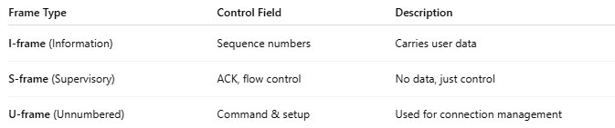
Frame Type | Control Field | Description
I-frame (Information) | Sequence numbers | Carries user data
S-frame (Supervisory) | ACK, flow control | No data, just control
U-frame (Unnumbered) | Command & setup | Used for connection management

